Massachusetts Department of Elementary and Secondary Education
Exchange Visitor Orientation Guide and Handbook

December 2023

Office of Educator Licensure
135 Santilli Highway
Everett, MA 02149
781-338-6619
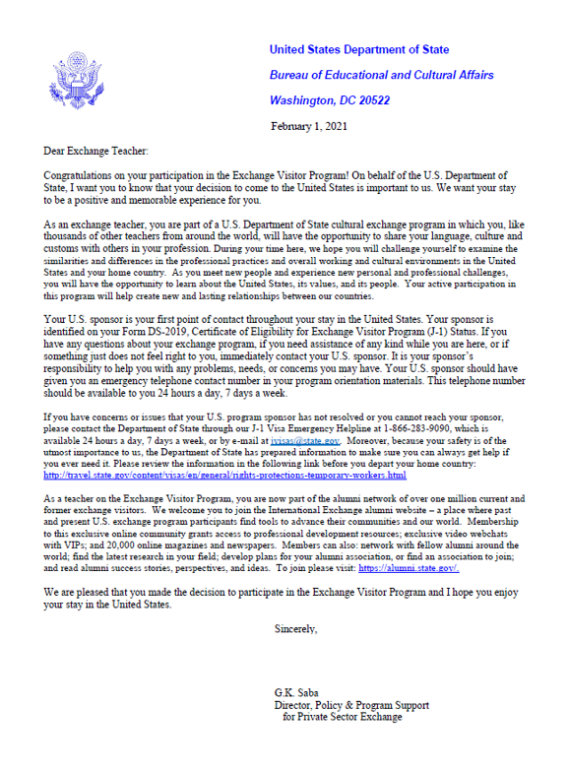

Table of Contents
Section 1: Welcome and Overview of the Exchange Visitor Program 1
Overview of The Exchange Visitor Program 2
Sponsors: 2
Education Advisors: 3
Section 2: Employment and Massachusetts Teacher Certification 4
Employment Information 5
Expected Work Related Deductions from Your Paycheck 5
Union Fees: 6
Retirement Fund Deductions: 6
MA Teacher Certification 6
Massachusetts Educator License: 7
Section 3: Moving to Massachusetts 8
Travel 10
Notification of Arrival, and Validation 10
Transportation from the Airport: 11
Housing 11
Getting Your Social Security Number 13
Obtaining Your Driver’s License 14
Using Your Driver's License from Your Home Country 14
How To Obtain a Massachusetts Driver’s License 14
Opening a Bank Account 15
Paying Taxes 15
Federal and State Income Taxes: 15
Employee Rights and Laws 16
Section 4: Life and Customs in the US / Massachusetts 18
Orientation(s) 19
Life and Customs in the US 19
Things to Do in and Around Boston 20
Local Community Resources, Public Transportation, and Libraries 20
Available Healthcare and Emergency Assistance 20
Public Transportation 21
Massachusetts Public Libraries 21
Section 5: Program Requirements / Regulations 22
How to Remain in Lawful Non-immigrant Status 23
Program Transfer Requests 23
Maintain Mandatory Insurance Coverage: 23
Cross-cultural activity component 24
Program Extensions 25
Returning Abroad/Traveling 26
The Home-Country Physical Presence Requirement 26
Addendum: Department of State BridgeUSA Brochures 27
Definitions: 33

Section 1: Welcome and Overview of the Exchange Visitor Program

Welcome!
On behalf of the Massachusetts Department of Elementary and Secondary Education (ESE), we welcome you to the Commonwealth of Massachusetts and look forward to your participation in the BridgeUSA Exchange Visitor Program. Please note that throughout this guide, the terms Exchange Teacher and Exchange Visitor are used interchangeably.

Overview of The Exchange Visitor Program
The U.S. Department of State administers the Exchange Visitor Program under the provisions of the Mutual Educational and Cultural Exchange Act of 1961. The program promotes mutual understanding between the people of the United States and other countries by means of educational and cultural exchange.

Sponsors:
The U.S. Department of State designates U.S. organizations such as government agencies, academic institutions, educational and cultural organizations, and corporations to administer exchange visitor programs. These organizations are known as sponsors.
The Massachusetts Department of Elementary and Secondary Education (ESE) has been an approved sponsor (Teacher category) since June 1999. ESE has sponsored over 360 Exchange Visitors during the 24 years that it has been a sponsor of the BridgeUSA Exchange Visitor program. The number of slots that the program has been approved to offer has varied from year to year. ESE is currently approved to sponsor 40 J-1 Exchange Visitors for the 2023-2024 school year.
ESE’s BridgeUSA program is managed by one Responsible Officer and two Alternate Responsible Officers. Your primary contact at ESE is Maria Frederick, BridgeUSA coordinator/Alternate Responsible Officer. Contact information is as follows:
Maria Frederick, Alternate Responsible Officer
Maria.L.Frederick@Mass.gov
781-338-6619
Massachusetts Department of Elementary and Secondary Education
Office of Educator Licensure
135 Santilli Highway
Everett, MA 02149
Brian Devine, Responsible Officer
brianj.devine@mass.gov
781-338-3124

Xin Yu, Alternate Responsible Officer
xin.yu@mass.gov
781-338-6626

Education Advisors:
The Department has a Memoranda of Understanding with Spain and Portugal and only sponsor qualified educators from those countries.
Spain:
Antonio Caballero Javierre
Education Advisor
Education Office
Consulate General of Spain
31 Saint James Av. Suite 905
Boston, MA 02116
T: 1 (857) 274-6572
antonio.caballero@educacion.gob.es

Portugal:
João Caixinha
Coordinator for the Portuguese Language Programs
and Education Affairs in the United States of America
31 St. James Avenue, 3rd floor, suite 350
Boston, MA 02116
T: 1 (617) 775 9161
joao.caixinha@camoes.mne.pt

Section 2: Employment and Massachusetts Teacher Certification

Employment Information
Employment information and terms and conditions of employment; address, position duration, job duties, number of work hours, wages, and other compensation and benefits are provided to each exchange teacher by their host school. Much of this information should be included in the offer of employment/contract that each exchange teacher receives and eventually agrees to and signs off on.
Teaching positions, including duties, responsibilities, hours of employment, and compensation, should be commensurate with those of similarly situated U.S. teachers within you school district or host school. ESE does not get involved with contract negotiations between the host school and exchange teacher, other than to ensure compliance with Federal Regulations. Please note that most school districts pay their educators on a bi-weekly basis (every other week) and as such you may not receive your first paycheck until two-three weeks after you begin working. Exchange teachers should bring enough money to cover the first month or two of their living expenses.

Expected Work Related Deductions from Your Paycheck
This varies by school district and will be provided to the exchange teacher by their host school/school district at the time that the exchange visitor is accepted into the program and prior to the exchange teacher signing their contract. Estimated work-related deductions can include but may not be limited to:
- Federal withholdings (Federal Tax) — range between 10–25% of gross income (total of all income from whatever source prior to deductions, money left after deductions is referred to as net income), rate dependent upon allowable deductions. Please note that some countries have applicable tax treaties with the United States, while others do not. Exchange teachers may wish to contact a professional tax return preparer to better understand their tax obligations or for guidance on how to prepare and submit their annual U.S. federal and state tax returns. Tax Information and Responsibilities for New Immigrants to the United States
- Nonresident alien students, teachers, trainees, researchers, and other aliens temporarily present in the United States in F-1, J-1, M-1, or Q-1 nonimmigrant status are *exempt from having to pay Social Security / Medicare Taxes on wages paid to them for services performed within the United States as long as such services are allowed by the United States Citizenship and Immigration Services (USCIS) for these nonimmigrant statuses, and such services are performed to carry out the purposes for which they were admitted into the United States. Taxation of Alien Individuals by Immigration Status
  - *The term “exempt individual” does not refer to someone exempt from U.S. tax but rather to a certain category of individual whose days of physical presence in the United States do not count for purposes of the Substantial Presence Test. Included within this category are students, teachers, and trainees.
  - There is a limit on the number of years a J-1 alien can be considered an “exempt individual” student, teacher, or trainee and exclude U.S. days of presence for purposes of the Substantial Presence Test.
    - Teacher or trainee – two calendar year rule:
    - Generally, a J-1 alien cannot exclude U.S. day of presence as a “teacher or trainee” for more than two calendar years.
    - Four-year exception: Subject to certain conditions, the two-year teacher or trainee limit can be extended up to four calendar years.
- Resident aliens are taxed in the same manner as U.S. citizens. In general, an alien in J-1 status (hereafter referred to as a "J-1 alien") will be treated as a U.S. resident for federal income tax purposes if he or she meets the Substantial Presence Test.
    - Medicare tax — 1.5% of gross income
    - Social Security tax — 6.2% of gross income
- What to do if the tax is withheld: If a J-1 alien falls into the category of employees who are exempt from Social Security and Medicare tax, he or she may discuss with his or her employer to stop withholding and refund amounts that were already withheld. Employees that are unable to obtain a refund from their employer may file Form 843, Claim for Refund and Request for Abatement and Form 8316, Information Regarding Request for Refund of Social Security Tax Erroneously Withheld on Wages Received by a Nonresident Alien on an F, J, or M Type Visa to obtain a refund.

Union Fees:
The school district is responsible for clarifying Union membership options and related fees to each Exchange Visitor/Teacher prior to, or as part of a job offer. Contact host school for more information; average cost is $650 per academic year

Retirement Fund Deductions:
Exchange Visitors/Teachers who are employed full-time in a Massachusetts public school are required to pay into the Massachusetts Teacher Retirement System (MTRS) even though they will eventually be returning back to their home country at the end of their program. It is the hiring school district’s responsibility to let each Exchange Visitor/Teacher know approximately what percent of their gross pay will be deducted from each paycheck and put into their retirement fund. MTRS contribution rates can be found at: https://mtrs.state.ma.us/members/#your-membership. Ideally this should be discussed prior to or as part of a job offer.
Exchange Visitors/Teachers will be able to apply for a refund of their retirement fund money upon separation of services. Exchange Visitors/Teachers should contact the MTRS http://www.mass.gov/mtrs/ for additional information related to obtaining a refund https://mtrs.state.ma.us/refund.

MA Teacher Certification
Massachusetts is committed to ensuring excellence within our schools and to supporting and developing our educator workforce. We are a national leader in education, and are looking for inspired, innovative, and nurturing individuals to join our schools. To be eligible for employment by a school district in any position covered by a license issued under 603 CMR 7.00, a person must have been granted a license by the Commissioner that is appropriate for the role. Potential licensure exemptions as it applies to exchange teachers is outlined in the next three paragraphs.
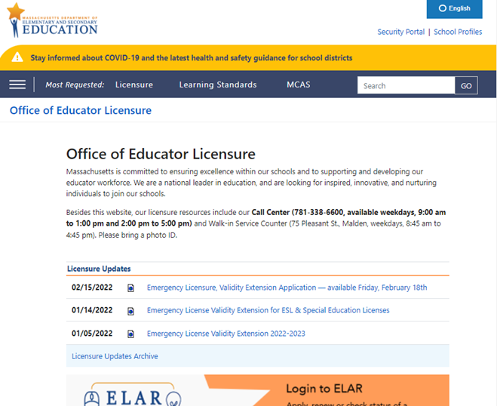

www.doe.mass.edu/licensure
Massachusetts Educator License:
Massachusetts Educator License Exemption: Traditional PreK–12 public school visiting teachers on J-1 visas are exempt from having to obtain a Massachusetts educator license; however, exchange teachers employed by a Charter School are subject to Charter School Regulations and may be required to obtain a MA license, endorsement, and/or pass MTEL tests to be legally employed. Please note that even if an exchange visitor is exempt from obtaining an educator licensure / endorsement by the state, a hiring school district may require an exchange teacher to hold a MA educator license or obtain the SEI or Bilingual Education endorsement. Spouses on a J-2 visa who obtain a work permit and are employed as a public-school teacher, are not exempt from the licensure requirements.

Position | Typically Endorsement Required
Teacher providing instruction in a language other than English | Bilingual Education Endorsement
Teacher providing instruction in English | Bilingual Education Endorsement  (Or)  Shelter English Immersion Endorsement

Section 3: Moving to Massachusetts
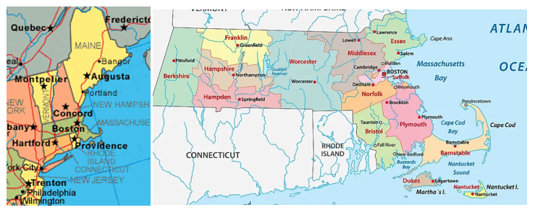
Pre-Arrival Checklist

- Apply for your visa:
  - See How to Apply for a Visa (Spain) https://ais.usvisa-info.com/es-es/niv/information/niv
  - See How to Apply for a Visa (Portugal) https://ais.usvisa-info.com/en-pt/niv/information/niv ;
- Pay the I-901 (SEVIS Fee), found online at https://www.fmjfee.com/i901fee/index.html be sure to print a copy of your payment receipt to bring to your visa interview. All J-1 visa applicants must pay the J-1 SEVIS fee of $220. The SEVIS fee must be paid at least three business days prior to your scheduled visa interview. Spouses and dependent children (J-2s) do not pay this fee. The SEVIS fee is not a visa application fee. It is used to operate and maintain the SEVIS database. The fee is non-refundable, even if the visa application is denied.
- Verify that all the information on your visa document is correct. Please inform Maria Frederick, Alternate Responsible Officer, Maria.L.Frederick@mass.gov, 781-338-6619, if your travel plans prevent you from arriving to the US prior to the start date listed on your visa document (found on your DS2019);
- Purchase or make plans to purchase medical insurance coverage. The U.S. Department of State requires all individuals who enter the United States in J-1 status to have medical insurance for themselves and any accompanying J-2 dependents. A minimum of $100,000 of insurance for your first two months of stay to ensure that you have health coverage until you get insurance coverage from your employer. Exchange teachers must also obtain medical evacuation (min. 50,000 coverage) and repatriation of remains insurance (min. 25,000 coverage) for the duration of your, and your family members stay.
- Arrange for your housing needs. Although ESE is unable to assist you in arranging housing, this guide provides an overview of housing resources; and
- Arrange for transportation from the Boston (Logan) airport to your hotel or apartment.

Travel
Exchange teachers beginning new programs may not enter the US more than 30 days before their program start date. Do not purchase a plane ticket or make travel arrangements until your J-1 visa is issued and in your passport. Most exchange teachers traveling to Massachusetts at the start of their program fly into Boston Logan International Airport https://www.massport.com/logan-airport/. An interactive map of the airport can be found at: https://maps.massport.com/.
You may need to present the following documents to the U.S. Customs and Border Protection (CBP) officer at the U.S. port of entry:
- Passport(s) containing a valid J-1 visa (for yourself and accompanying family members);
- Signed Form DS-2019(s) for you and any accompanying family members (always make sure to keep all copies of your DS-2019 with you when traveling,
- Proof of financial support (same as the documentation presented at the U.S. Embassy or Consulate).

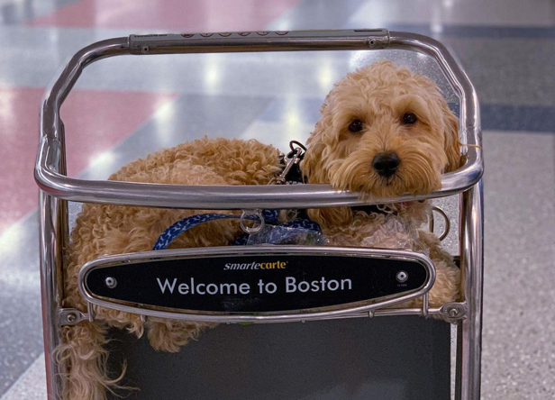

Notification of Arrival, and Validation
Your Form DS-2019 was created in a computerized system known as the Student and Exchange Visitor Information System (SEVIS). This System is administered by the Department of Homeland Security and is used to collect and maintain information on the current status of non-immigrants and their dependents in the sponsor’s program during their stay in the United States. Your program cannot be validated in SEVIS until you arrive in the US. Upon arrival to the U.S. an Exchange Visitor(EV) must provide their temporary or permanent address to their sponsor. The EV is then moved off of Initial status in SEVIS and their program validated in SEVIS. At this point they can then move forward with their application for a Social Security Card (guidance on applying for a Social Security Card can be found later on in this guide). When you arrive in the United States, please contact Maria Frederick, Maria.L.Frederick@Mass.gov, to ensure that your data in SEVIS is updated.

Transportation from the Airport:
Boston Logan International Airport is located is located mostly in East Boston on the east coast of Massachusetts. There are many travel options to consider when traveling from the airport to your temporary / permanent home. The best one to utilize will depend upon your final destination. Public transportation is available depending upon the amount of luggage you have to carry and how far you are traveling outside of Boston. There is a variety of car rental options available onsite as well. If you are planning on renting a car upon your arrival, you should consider reserving one through the rental agency well in advance to ensure availability.
If you are arriving late in the day, you may wish to rent a hotel room at/near the airport and put off traveling to your temporary accommodation the next day.
Car Rental Information: https://www.massport.com/logan-airport/at-the-airport/car-rental-center/
Public transportation and other available options: https://www.massport.com/logan-airport/to-from-logan/transportation-options/

Housing
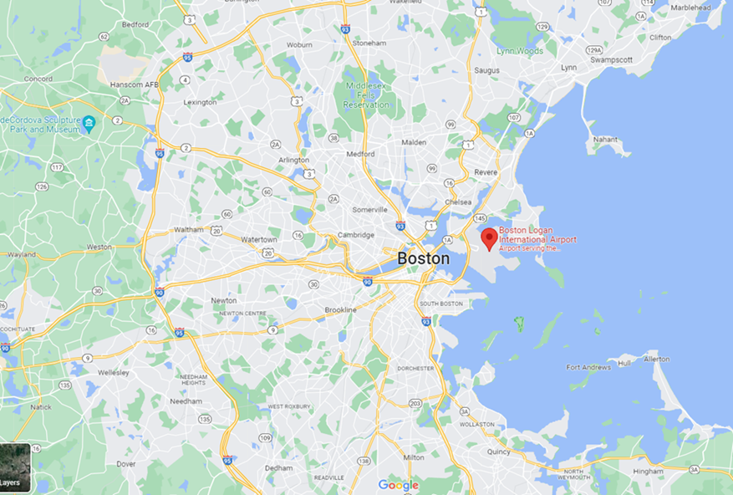
The cost of renting a one-bedroom apartment can range from $1750 to $3500+ a month depending on location and amenities. Rents in and around the Boston area have increased significantly in recent years. In many cases you will need to obtain a Social Security Number (SSN: see section on obtaining a Social Security Number) and bank account prior to being able to sign a lease / rental contract. You may need to obtain temporary housing until you receive your SSN. This process could take a few weeks to complete.
If you require temporary accommodations for a few weeks or more, you may wish to find a hotel/rental
with kitchen facilities as it can get very expensive to eat out every day. You can find furnished and unfurnished apartments throughout Massachusetts, but rental costs and convenience (distance to school, public transportation, shopping, etc.) can vary significantly.
Renting an apartment, decisions you will need to make:
- What is your annual budget, including monthly rent, heat, hot water and broker’s fee?
- How close do you want to live to your school?
- Do you want to live alone or have roommates?
- If you’re bringing a family, and have children that need to attend public school what is the distance to their school and how will they get there, i.e. school bus or public transportation?
- Are you looking for a furnished or unfurnished apartment?
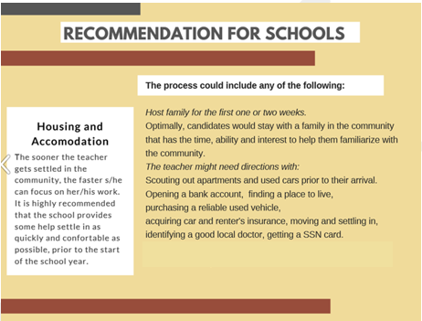
Other considerations:
- What is the lease commitment? (For your first rental, upon arrival, it is advisable not to
sign a one-year lease until you are more familiar with the renting process, location, etc.)
- How safe is the neighborhood?
- Are heating and hot water included with your monthly rent?
- Is there a laundry facility?
- Will the apartment be noisy (Is it near an elevator or entry? Are the walls thin?)?
- Is the apartment, especially the kitchen and bathroom, in good and clean condition?
- Are you allowed to keep a bicycle in your apartment or in the basement?
- Are there any security features (particularly for ground floor apartments)?
- What is the overall size of living space?
- If you have roommates, how will the utility bills be shared?
- Is there sufficient natural sunlight and/or overhead light fixtures?
- Is the apartment close to public transportation?
- Is there a grocery store or shopping nearby?
Also, there are several *rental agencies that can help you find an apartment. A few of them are listed below.
- Airbnb
- Zillow
- ApartmentFinder.com
- Realtor.com
(*Please note the above list is provided for your convenience and does not constitute an endorsement of these agencies by ESE.)

Getting Your Social Security Number
Why do you need one?
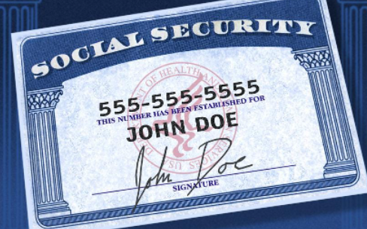
A Social Security number is important because you need it to get paid, open a bank account, and as well as obtain housing and purchase/lease a car. You should keep your Social Security card in a safe place with your other important papers and avoid giving it out unnecessarily. Keep in mind that in many cases, even if you lost your card, you may not need a replacement. In most cases, simply knowing your Social Security number is enough.
Applying for a SSN Upon Arrival to the U.S: Upon arrival to the U.S. an Exchange Visitor (EV) must provide their temporary or permanent address to their sponsor. The EV is then moved off of Initial status in SEVIS and their program validated. At this point they can then move forward with their application for a Social Security Card.
As of August of 2022, some Social Security offices in the U.S. are still closed, while others are open by appointment only, while still others are open completely. Each regional office has their own processes and protocols in place for the handling of applications. Some offices require non-citizens to mail in their Social Security Card application https://www.ssa.gov/forms/ss-5.pdf with supporting documents in advance of obtaining an appointment. Some Social Security offices do not allow exchange teachers to submit their applications until after their program start date as noted on your DS-2019s; therefore, if you arrive in MA prior to your program start date, you may not be able to start this process right away. It can take 1-3 weeks to get your Social Security number/card mailed to you once the application is submitted. Please note that you will still be able to receive a paycheck even if you have not yet received your SSN.
Exchange Visitors should call their local office for guidance specific to their region. To find the local office they can use this locator https://secure.ssa.gov/ICON/main.jsp.
I-94 - Form I-94 is the Department of Homeland Security’s Arrival/Departure Record issued to non-resident aliens who are admitted to the U.S., who are adjusting status while in the U.S. or extending their stay, among other things. A Customs Border Protection (CBP) officer will scan a traveler’s passport, generating an electronic arrival record with data elements found on the current paper Form I-94. CBP will make the electronic I-94 available at www.cbp.gov/I94. Travelers may visit this website to print their electronic I-94 number before applying for immigration or public benefits, such as a driver’s license or a Social Security number.
Spouses cannot apply for their SSN until he/she has their work permit. If they apply for a SSN prior to obtaining this, it is normal for he/she to be denied and it could potentially red flag the educator on the J-1 visa causing a delay in their getting a card. If this happens and both applications are denied, there is a process through which the issue can be rectified, but that could take weeks. Typically, the educator on the J-1 will receive permission enabling them to work while awaiting the review and verification. If they are ultimately denied, they would have to file a claim.

Obtaining Your Driver’s License
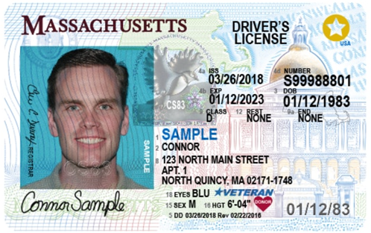
For purposes of identification and licensing, the Massachusetts Registry of Motor Vehicles issues driver's licenses. Different driver's licenses can be used to operate different classes of vehicles. The most common is the passenger (Class D) license, which allows you to legally operate a passenger vehicle, van or small truck. You must have a valid driver’s license to drive in the U.S. You will find additional information on how to obtain a Massachusetts’s driver’s license at The Massachusetts Registry of Motor Vehicles (RMV) .
If you will drive in the U.S., the Massachusetts Registry of Motor Vehicles (RMV) advises you to obtain a Massachusetts Driver’s License within 30 days of moving to Massachusetts

Using Your Driver's License from Your Home Country
- Foreign licensed drivers from any country may operate a validly registered motor vehicle in Massachusetts as long as they meet certain requirements. The list of requirements is on can be found at the following website: https://www.mass.gov/service-details/driving-in-massachusetts-on-a-foreign-drivers-license.

How To Obtain a Massachusetts Driver’s License
To get a driver’s license in Massachusetts, you’ll need to provide a Social Security Number and proof of Massachusetts residency. You will also need to provide valid, verifiable immigration documents as well as proof that you've been granted a legal stay in the U.S. for at least 12 months (DS-2019/Visa). Your license will expire when your legal stay is over.
Step 1: Apply for a Passenger (Class D) Learner’s Permit and take the Written Learner's Permit Test https://www.mass.gov/how-to/apply-for-a-passenger-class-d-learners-permit.
- To prepare you may wish to read the Massachusetts Driver's Manual.
Step 2: Pass a road test https://www.mass.gov/how-to/schedule-your-road-test
- After you obtain a Learner's Permit and become accustomed to driving in the U.S. (usually 6 months), you will schedule a road/driving test.
- You are required to bring a car to the road test. The road test is usually brief, and you may borrow/rent a car for this purpose.
The following website can help you locate an RMV office near you: https://www.mass.gov/orgs/massachusetts-registry-of-motor-vehicles/locations.

Opening a Bank Account
Most US banks will require non-residents to apply for an account in person. That means you have to travel to the US and walk into a bank branch to set up your account. Here’s a list of what you may need to open your new bank account:
- A valid, government-issued photo ID, such as a driver’s license or a passport. Nondrivers can get a state ID card at the Registry of Motor Vehicles (RMV).
- Other basic information, such as your birthdate, Social Security number or Taxpayer Identification Number, or phone number.
- An initial deposit is typically required.
Additional information can be found at: https://www.mass.gov/service-details/savings-and-checking-accounts.

Paying Taxes
Federal and State Income Taxes:
The school district/host school is required to withhold taxes (see Expected Work Related Deductions from Your Paycheck in the Employment section of this guide) from the paycheck of an exchange visitor. Exchange visitors are required to file yearly federal and state tax returns by the April due date (https://www.irs.gov/Individuals/International-Taxpayers).
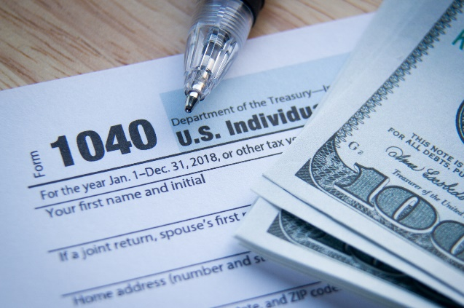
For federal tax purposes, an alien is an individual who is not a U.S. citizen. Aliens are classified as nonresident aliens and resident aliens. The U.S. Tax Guide for Aliens will help you determine your status and provide guidance on how to file your U.S. tax return (Federal).
This Photo by Unknown Author is licensed under CC BY-ND
Exchange visitors can visit the Massachusetts Department of Revenue’s website for guidance on determining their residency status as well as filing their state tax return http://www.mass.gov/dor/individuals.
An exchange visitor may wish to seek the advice of a tax expert to better understand his/her general tax obligation (alien classification and applicable tax treaties) while participating in the Exchange Visitor program.

Employee Rights and Laws
Exchange teachers have certain rights which are protected by both state and federal laws. These include the right to fair wages, a safe work environment, workers’ compensation and more. Information specific to worker’s rights and safety expectations as covered by Massachusetts’s laws can be found at: https://www.mass.gov/topics/workers-rights-safety.
Per Federal Regulations, exchange teachers can expect that their teaching positions, including duties, responsibilities, hours of employment, and compensation, are commensurate with those of similarly situated U.S. teachers in the school district or host school where that exchange teacher is assigned to teach.
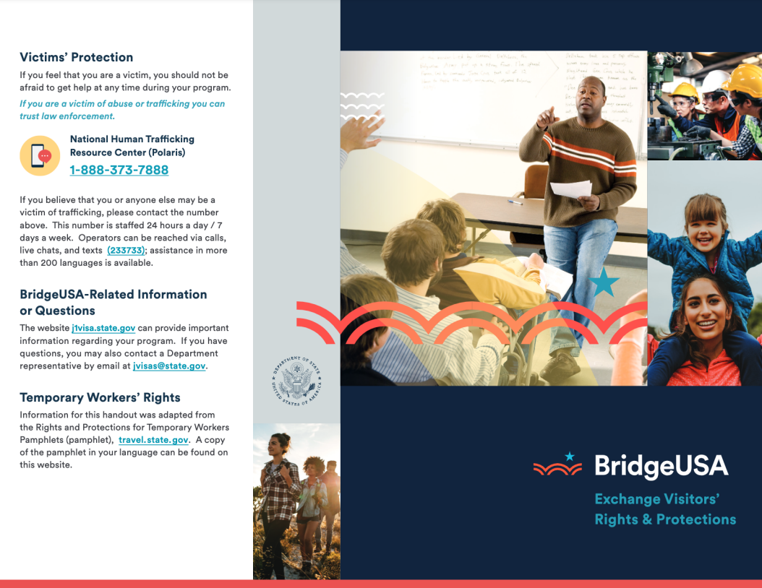

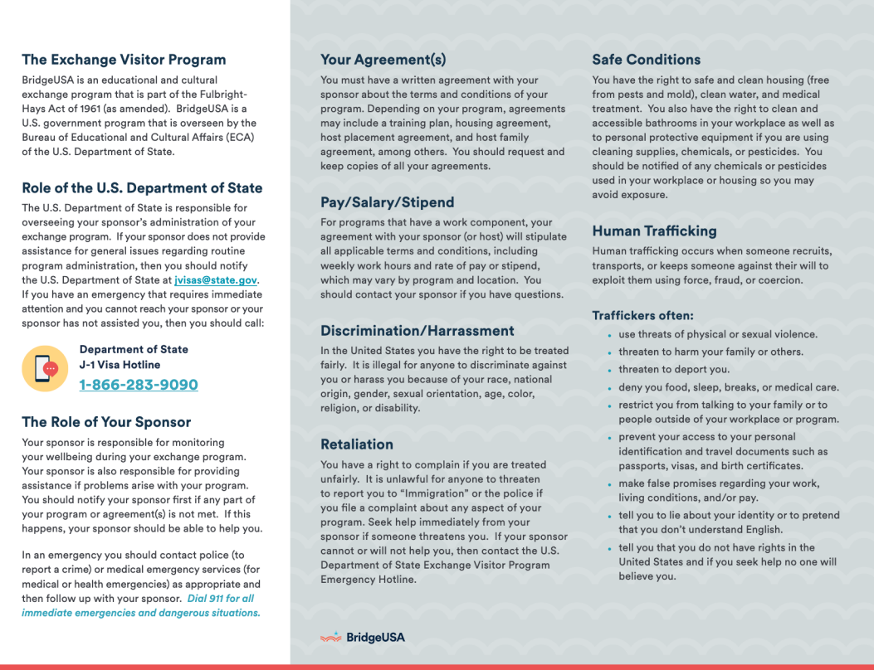

Section 4: Life and Customs in the US / Massachusetts

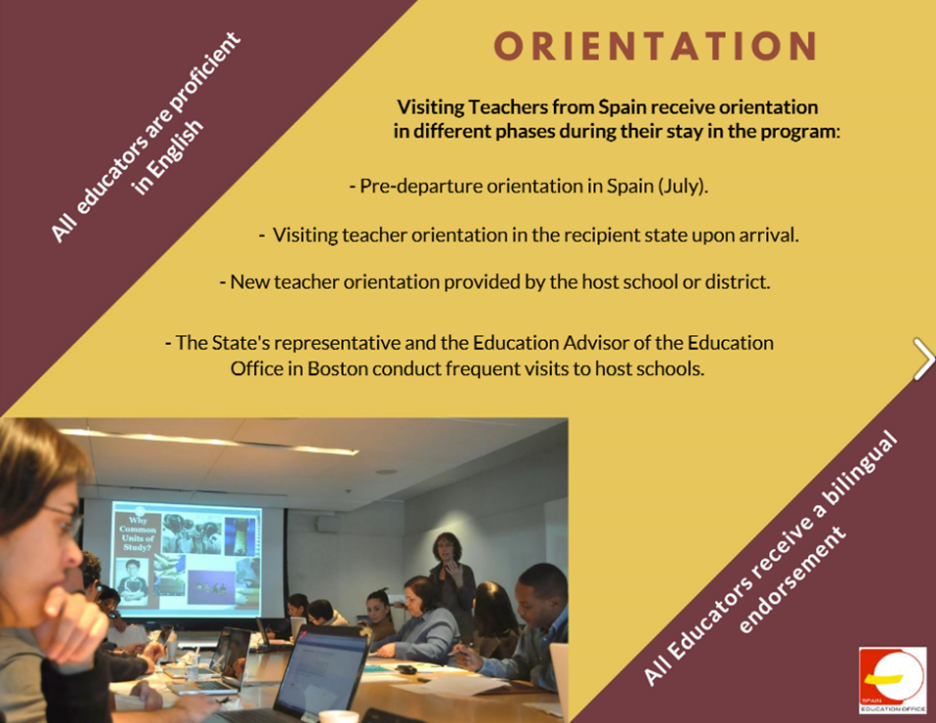
Orientation(s)
Visiting teachers from Spain receive orientation in different phases during their stay. All exchange teachers shall be provided with a new teacher orientation by their host school / district. A review of all of the information in this guide, shall be a part of that orientation.

Life and Customs in the US
America is a melting pot of indigenous people and immigrants from all corners of the world both newly arrived and those who can trace their ancestries back to those who immigrated to the US before the founding of the country itself. Although most Americans only speak English, many can speak multiple languages and in many major cities, small pockets of neighborhoods devoted to the culture of one particular ethnicity can be found, enabling a visitor to feel transported to another country altogether.
In the city of Boston one can spend the morning in the North End enjoying Italian cuisine, and then head over to Chinatown to sample authentic dumplings and other Chinese and Asian cuisines. Of course, it must be noted that 16 communities within the South Shore neighborhoods of Boston have the highest percentage of people of Irish descent in the United States. Global Boston provides a look at a variety of immigrant settlement in greater Boston, between 1870-2010 https://globalboston.bc.edu/index.php/home/immigrant-places/.
North America contains just about every type of biome there is. You can travel to a rainforest, desert, coniferous forest, prairie, tropical beaches, and surf in two of the world’s five oceans, without leaving the country.
- General information regarding life in the US to include federal holidays, American money, and the US Government can be found at: https://www.usa.gov/life-in-the-us.
- The Smithsonian Institution, located in Washington D.C. is the world’s largest museum, education, and research complex. It is a wonderful resource to explore American history and culture: https://www.si.edu/explore/history
- Massachusetts Legal Holidays: https://www.sec.state.ma.us/cis/cishol/holidx.htm

Things to Do in and Around Boston
The Arts:
- Museum of Fine Arts
- Broadway in Boston
- Boston Symphony Orchestra
Historical:
- USS Constitution
- The Freedom Trail
- Boston Tea Party Ship
- Faneuil Hall Marketplace
- Salem Witch Trials/Salem MA
Science:
- Museum of Science Boston
- New England Aquarium
Sports:
- Red Sox (Baseball)
- Bruins (Hockey)
- Celtics (Basketball)
- Patriots (Football)
- New England Revolution (Soccer)

Local Community Resources, Public Transportation, and Libraries

Available Healthcare and Emergency Assistance
The process of finding a Primary Care doctor for you and/or your family will vary based upon where you live and the type of health insurance that you have. A quick search of the internet will provide you with names and locations of local hospitals and/or doctor’s practices and can enable you to find a health provider who is a good fit for you. Your health insurance provider will most likely have a list of in-network providers that you can choose from as well.
Emergency care can be obtained on a walk-in basis at the Emergency Room of the local hospital. If you are unable to get to an Emergency Room or need urgent medical care, help can be obtained by dialing 911. 911 should also be dialed in the case of an emergency that requires the help of a police officer or fire fighter. The operator is trained to ensure you receive the right type of help whether it be an ambulance, police officer, fire fighter, or some combination of the three. Information specific to when and how to access the nation’s 911 emergency services number can be found at: https://www.fcc.gov/general/9-1-1-and-e9-1-1-services.
In situations where you are unable to see your doctor and are not sick enough to warrant a trip to an Emergency Room, you can obtain medical help from a medical provider at one of the many urgent care facilities located around the state. Again, a quick online search for an urgent care office near you should provide you with many non-emergency options from which to obtain healthcare.

Public Transportation
Most major cities offer some form of public transportation whether it be, bus, train, or subway. Information on accessing public transportation in and around Boston can be found on the Massachusetts Bay Transportation Authority’s website: https://www.mbta.com/.
Some of the major highways in Massachusetts and New England require the payment of a toll when driving on those roads. Many residents make use of Massachusetts' all electronic tolling program. It includes E-ZPass MA and Pay By Plate MA. The program works without toll booths on the Mass Turnpike (I-90), Tobin Memorial Bridge, and the Sumner, Callahan, and Ted Williams Tunnels. Information on Massachusetts electric tolling system can be found at: https://www.mass.gov/ezdrivema.

Massachusetts Public Libraries
Massachusetts has over 370 public libraries that provide residents with the opportunity to borrow books and other media for free. They are an invaluable resource providing access to literature, the internet, and other types of media. Many of them also offer residents with discounted or free passes to many museums. The public library in the town where you live, work, or study can help you get a library card. There is no charge for a library card, though some towns may ask a small fee for out-of-state residents or lost card replacements.
Each library has its own procedures for giving out cards. The Massachusetts Libraries Board of Library Commissioners has a searchable library database enabling you to locate a library near you. https://mblc.state.ma.us/index.php.

Section 5: Program Requirements / Regulations

How to Remain in Lawful Non-immigrant Status
Exchange visitors must report to their sponsor or sponsor designee within ten calendar days any changes in his or her telephone number, email address, actual and current U.S. address (i.e., physical residence), and site of activity. Exchange visitors may not change their site of activity without obtaining permission from their sponsor first.

Program Transfer Requests
Regulations do not prohibit the transfer of an exchange teacher to a different school in the same or different district or state, when warranted. Although exchange teachers enter into contracts with host schools, structured processes exist that make it possible for a sponsor to evaluate an exchange teacher’s request to transfer between host schools and/or school districts. At a minimum, changes in the site of activity will be considered when circumstances at the current site of activity may significantly affect the health, safety, and welfare of the exchange teacher.
The Department of State offers the following examples of situations in which the transfer of an exchange teacher may be warranted:
• A host school’s inability to continue compensating the exchange teacher according to the
terms of the employment contract;
• Unsuitable conditions that are beyond the exchange visitor’s control, e.g., a geographic area
that is unsafe or too expensive, or a hostile work environment; and
• A host school’s loss of its accreditation.
If an exchange teacher’s request to be transferred to a different school is denied, s/he has the
right to submit a complaint to the Department if the denial is negatively affecting health, safety, or welfare.
Approval of a change in the site of activity to another school or school district does not preclude an exchange teacher from extending his or her program. Although the language of the extension provision requires evidence of performance and cultural activities during the “previous three years,” only the host school at which the exchange teacher is placed at the time an extension is requested must submit a reference letter

Maintain Mandatory Insurance Coverage:
- Sponsors must require that all exchange visitors have insurance in effect that covers the exchange visitors for sickness or accidents during the period of time that they participate in the sponsor's exchange visitor program. In addition, sponsors must require that accompanying spouses and dependents of exchange visitors have insurance for sickness and accidents. Sponsors must inform all exchange visitors that they, and any accompanying spouse and dependent(s), also may be subject to the requirements of the Affordable Care Act.
(b) The period of required coverage is the actual duration of the exchange visitor's participation in the program as recorded in SEVIS in the “Program Begin Date,” and as applicable, the “Program End Date”. If the sponsor provides health insurance or arranges for health insurance to be offered the exchange visitor, via payroll deduction at the host organization, the exchange visitor must voluntarily authorize this action in writing and also be given the opportunity to make other arrangements to obtain insurance. These authorizations must be kept on file by the sponsor. Minimum coverage must provide:
(1) Medical benefits of at least $100,000 per accident or illness;
(2) Repatriation of remains in the amount of $25,000;
(3) Expenses associated with the medical evacuation of exchange visitors to his or her home country in the amount of $50,000; and
(4) Deductibles not to exceed $500 per accident or illness.
(c) Insurance policies secured to fulfill the requirements of this section:
(1) May require a waiting period for pre-existing conditions that is reasonable as determined by current industry standards;
(2) May include provisions for co-insurance under the terms of which the exchange visitor may be required to pay up to 25% of the covered benefits per accident or illness; and
(3) Must not unreasonably exclude coverage for perils inherent to the activities of the exchange program in which the exchange visitor participates.
…
(h) Accompanying spouses and dependents are required to be covered by insurance in the amounts set forth in paragraph (b) of this section. Sponsors must inform exchange visitors of this requirement, in writing, in advance of the exchange visitor's arrival in the United States.
(i) Exchange visitors who willfully fail to maintain the insurance coverage set forth above while a participant in an exchange visitor program or who make material misrepresentations to the sponsor concerning such coverage will be deemed to be in violation of these regulations and will be subject to termination as an exchange visitor.
(j) Sponsors must terminate an exchange visitor's participation in their program if the sponsor determines that the exchange visitor or any accompanying spouse or dependent willfully fails to remain in compliance with this section.

Cross-cultural activity component
Exchange teachers must obtain a letter from the head of a school in another country, preferably your home country, which states that school's willingness to work with you on the required cross-cultural activity component of the program. The letter submitted as part of your application package must be signed by the head of the school or another individual in an appropriate position of authority to speak for the school within the foreign country's school system; the official signing the letter must list both email and telephone contact information. The letter may be submitted in English or in the original language of the home country with an English translation; the name, title/organization and contact information of the translator must be noted on the translation.
Exchange teachers must complete, within the United States, and during each academic year of program participation, at least one cross-cultural activity from each of the following two categories for a total of two activities:
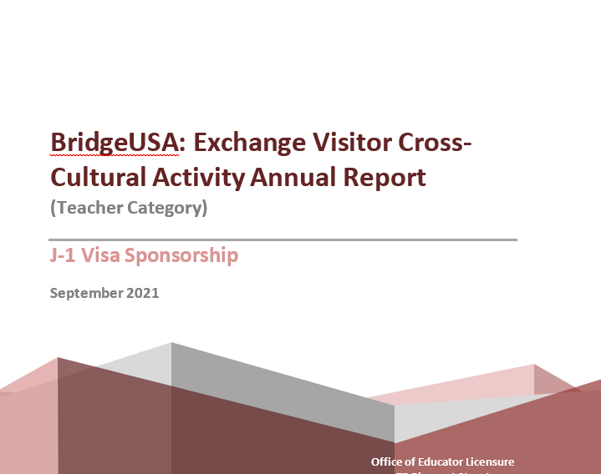
(i) An activity for the teacher's classroom, larger host school or host school district population, or the community at large designed to give an overview of the history, traditions, heritage, culture, economy, educational system and/or other attributes of his or her home country. Sponsors of exchange teachers placed at international schools must require their exchange teachers to conduct at least one cross-cultural activity per academic year outside the host school in nearby schools or communities where international opportunities may be more limited than those found in their host school: and
(ii) An activity that involves U.S. student dialogue with schools or students in another country, preferably in the exchange teacher's home school, through virtual exchange or other means, in order to supplement the goals of the in-person exchange.
Exchange teachers must submit an annual report to the ESE detailing the cross-cultural activity component of their exchange program to include both of the completed activities. The annual report must include the exchange teacher's full name and the program sponsor's name.

Program Extensions
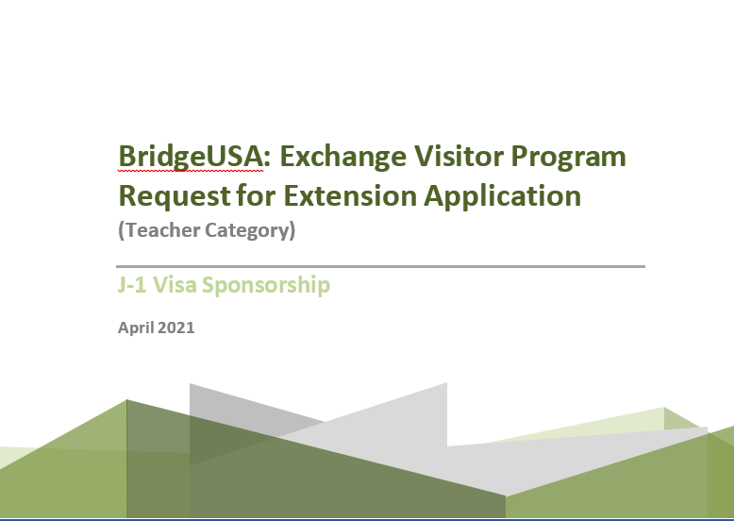
Exchange visitors are contacted well before the end of their program to gauge their interest in a potential program extension. If you are interested in extending your program for an additional one to two years you will be required to submit an application and all supporting documents to the Responsible or Alternate Responsible Officer of your program. Sponsors must submit all requests simultaneously to the Department of State (DoS) who then reviews the requests. Requests for extensions are not Guaranteed. The DoS could choose to approve an extension of an exchange teacher's exchange program by either one or two years, but not by a semester or by other fractions of academic years, or they could deny it completely. If the Department of State only approves a one-year extension, the exchange teacher can re-apply the following year for an additional year’s extension.
Requests for extension must include:
- A letter of reference on official letterhead written by the host school or host school district administrator responsible for overseeing the exchange teacher that describes the exchange teacher's performance during the previous three years of the exchange and how the host school has benefited from the exchange teacher's presence; and
- a document describing how the exchange teacher over the previous three years has engaged his or her classroom, the wider host school or host school district, or community through the cross-cultural activity component, if these activities are not already detailed in the exchange teacher's annual reports.
- the required non-refundable extension fee, currently $367.00 per applicant.
- All required documents/completed application must be submitted to your sponsor (MA DESE) no later than March 1st or the request for extension will not be processed.

Returning Abroad/Traveling
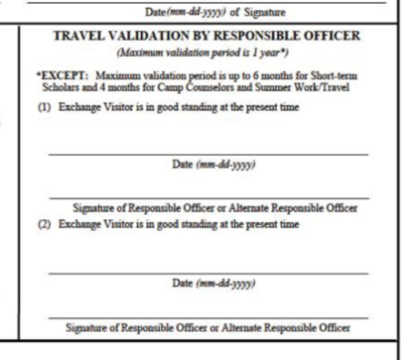
The Responsible or Alternate Responsible Officer’s signature is required on the DS-2019 form when traveling to and from the U.S. The travel signature is valid for only one year and updated signatures should be requested well in advance of your desired departure to allow for processing and mailing time (if applicable). DS-2019s documents may now be scanned and emailed to maria.l.frederick@mass.gov who will electronically sign and email back the document. All hard-copies should be kept together during travel out of and back into the country.
The 30-days following the completion of your J-1 program is considered the grace period and you'll no longer be under J-1 status but now under the overall jurisdiction of the United States Citizenship and Immigration Services. Within those 30 days, you must depart the United States.

The Home-Country Physical Presence Requirement
Exchange teachers who have successfully completed teacher exchange programs are eligible to participate in additional teacher exchange programs, provided that they have resided outside the United States for at least two years following the successful completion of their most recent teacher exchange program and continue to meet the eligibility requirements.

Addendum: Department of State BridgeUSA Brochures
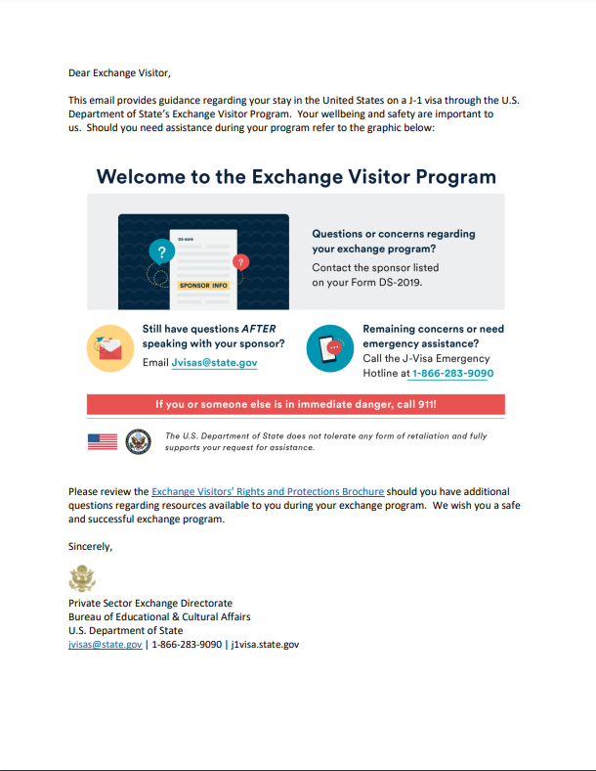
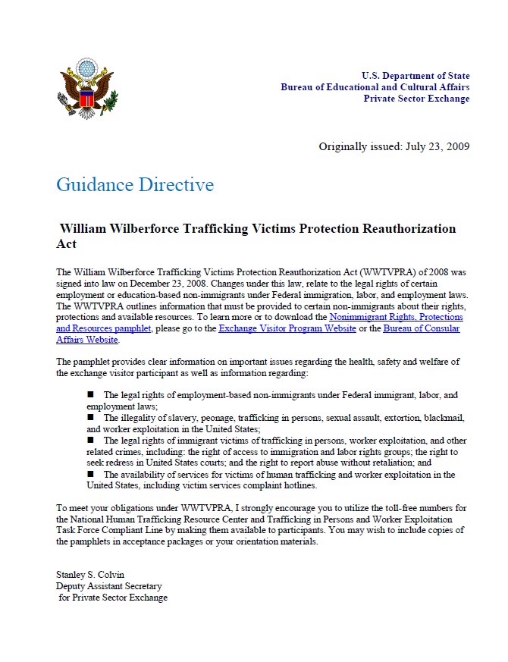
Wilberforce Pamphlet on the Rights and Protections for Temporary Workers
The Exchange Visitor Program Welcome Brochure
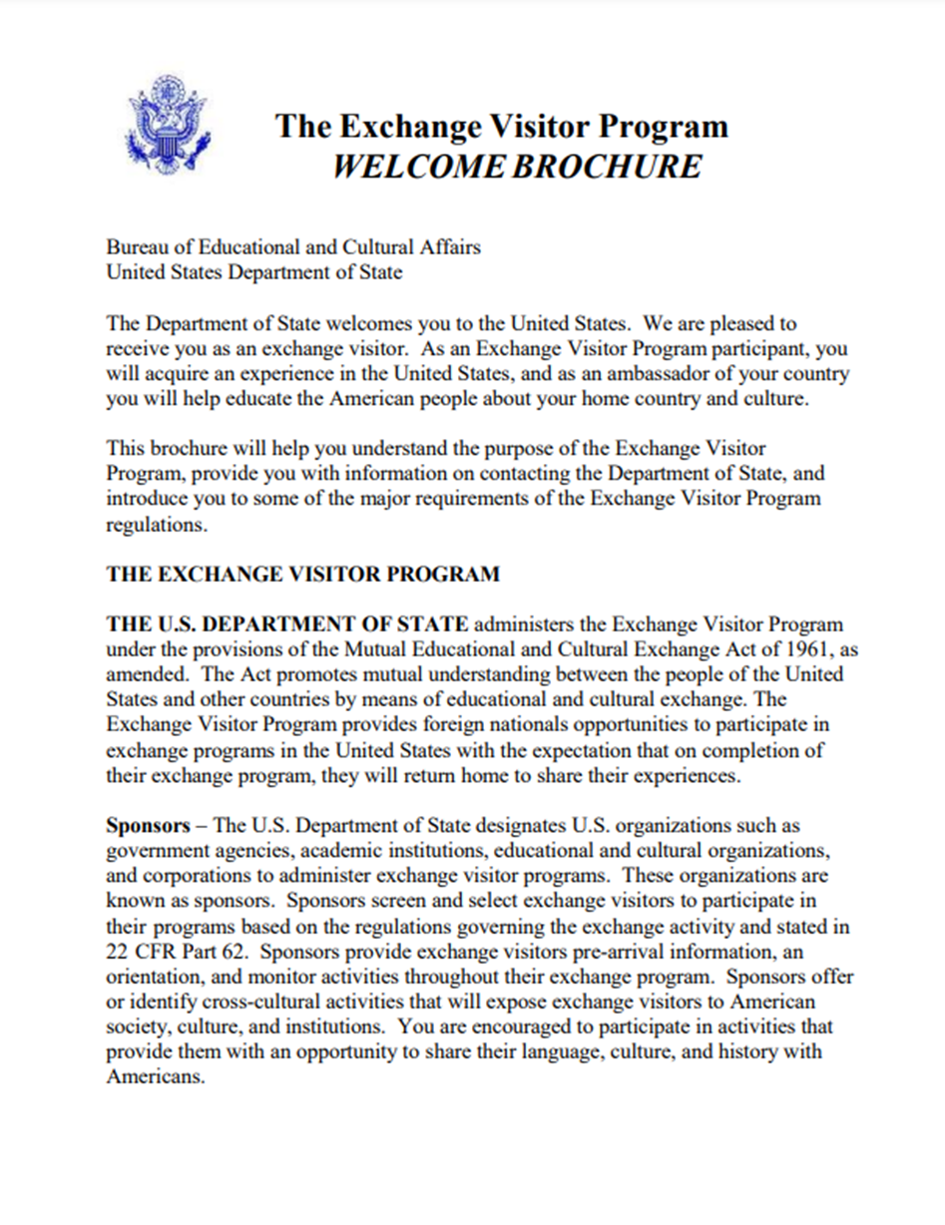
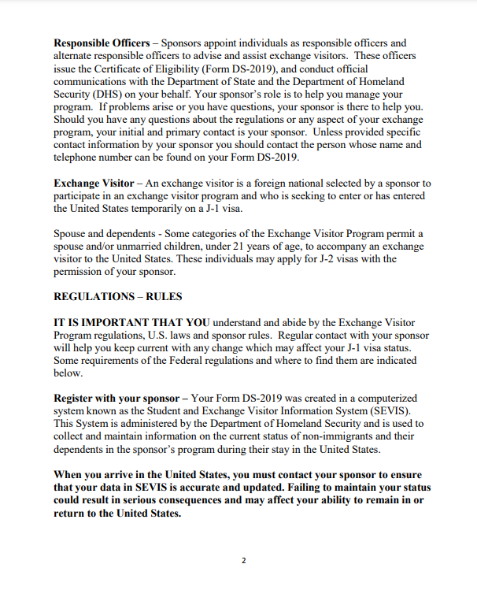

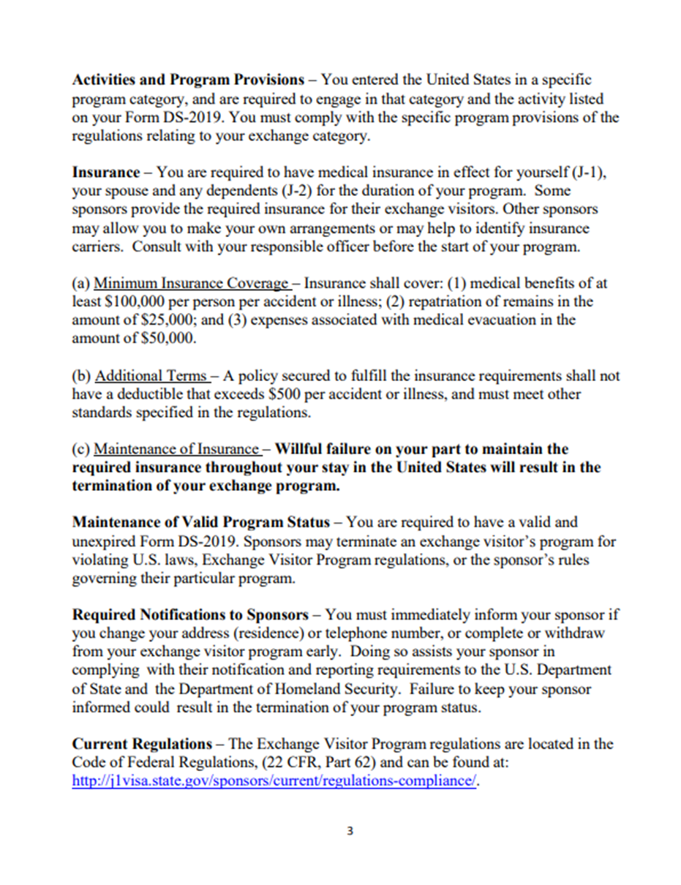
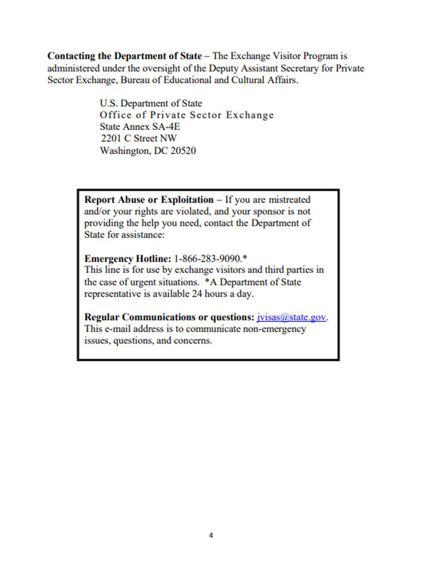

Definitions:
Dual language education'' or ''2–way immersion'', a program designed to promote bilingualism and biliteracy, cross-cultural competency and high levels of academic achievement for both native English speakers and English learners from a single language background; provided, however, that students shall develop and maintain their first language while adding a second language and shall receive the same core curriculum as all students in the state; provided further, that the instruction for such students shall be provided in 2 languages throughout the program; and provided further, that ''2–way immersion'' programs may begin in the early grades, including pre-kindergarten and kindergarten, and may continue through the secondary level.
''English as a second language'', instruction designed to help students become proficient in English and learn content simultaneously by providing systematic, sustained language instruction to develop the high level of English language proficiency needed for academic achievement; provided, that ''English as a second language'' instruction may focus on academic language and developing the ability of a student to listen, speak, read and write in English across a variety of social and academic contexts, to promote language development and support content area learning of the English learner in grade-level academic classrooms.
''English language classroom'' means a classroom in which the language of instruction used by the teaching personnel is overwhelmingly the English language, and in which such teaching personnel are fluent and literate in English. English language classrooms encompass both English language mainstream classrooms and sheltered English immersion classrooms.
''English language mainstream classroom'' means a standard classroom, one in which the students either are native English language speakers or already have acquired reasonable fluency in English.
''English learner'', a student who does not speak English or whose native language is not English, and who is not currently able to perform ordinary classroom work in English.
''Foreign language'', a language other than English.
''Language acquisition program'', an instructional program for English learners that includes English language instruction as a component to achieve fluency.
''Sheltered English immersion'' educational methodology - English language acquisition process for children in which nearly all classroom instruction is in English but with the curriculum and presentation designed for children who are learning the language. Instruction materials are in English and all reading, writing, and subject matter are taught in English. Teachers may use a minimal amount of the child's native language when necessary. No subject matter shall be taught in any language other than English, and children in this program learn to read and write solely in English.
''Transitional bilingual education'', a program designed to allow English learners to achieve long-term academic success through English-medium instruction in general education classrooms; provided, however, that the native language of the English learner is used to support the student's development of English and content learning and is then gradually phased out of instruction as a student's English proficiency increases; and provided further, that ''transitional bilingual education'' may be initiated at any level, including middle and high school, but shall not be intended as a method of instruction for a student's entire academic career.

